# I – Index:

|  |  |  |  |  |
| --- | --- | --- | --- | --- |
| CatBoost: unbiased boosting with categorical features | [CatBoost: unbiased boosting with categorical features (neurips.cc)](https://proceedings.neurips.cc/paper_files/paper/2018/file/14491b756b3a51daac41c24863285549-Paper.pdf) | Liudmila Prokhorenkova1,2 , Gleb Gusev1,2 , Aleksandr Vorobev1 , Anna Veronika Dorogush1 , Andrey Gulin | 2018 | Research Paper |
| **CatBoost in Machine Learning** | [CatBoost in Machine Learning - GeeksforGeeks](https://www.geeksforgeeks.org/catboost-ml/) |  | 2024 | Technical Doc |
| **Binary classification using CatBoost** | [**Binary classification using CatBoost - GeeksforGeeks**](https://www.geeksforgeeks.org/binary-classification-using-catboost/) |  |  | Technical Doc |
|  | [**MultiLabel Classification using CatBoost - GeeksforGeeks**](https://www.geeksforgeeks.org/multilabel-classification-using-catboost/) |  |  | Technical Doc |

# II- Notes:

*which involves sequentially adding decision trees to minimize errors. It effectively handles categorical features without requiring preprocessing, reducing overfitting with techniques like symmetric weighted quantile sketch*



## CatBoost Comparison results with other Boosting Algorithm

## Features:

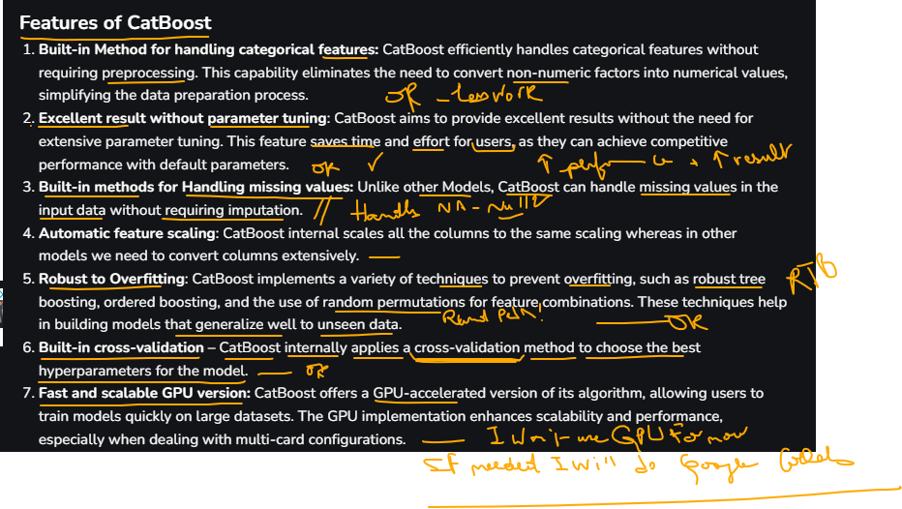

## Metrics:

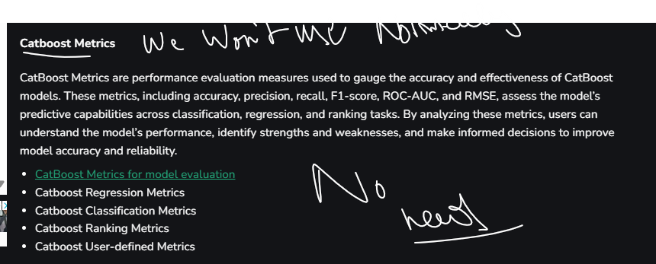

Nehna bel supervised, aslan ma eena ktir data, w kermel prediction eemlin parallelism using Swifter

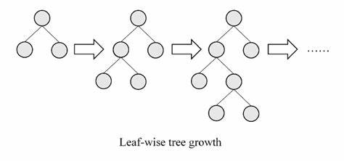 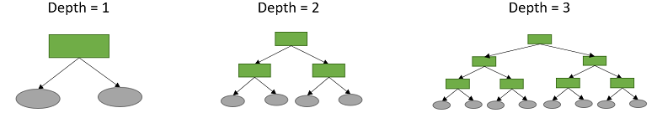

## Limitations of CatBoost:

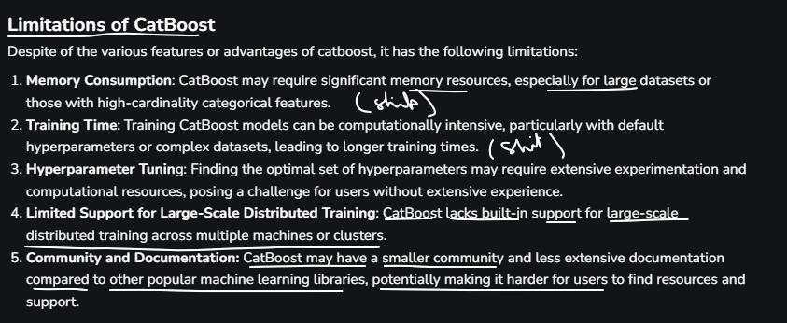



In my opinion; the number of epochs … Can be modified when we reach the level that measures the accuracy

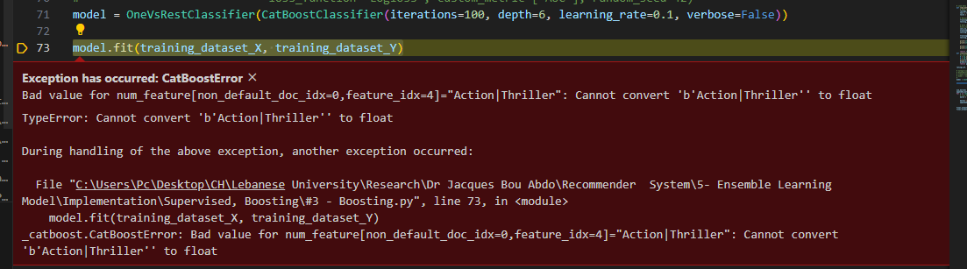



This is for multi class, means a dog is a dog and an animal and ….

I saw another method here:

[python - CatBoostClassifier static order of features - Stack Overflow](https://stackoverflow.com/questions/67414615/catboostclassifier-static-order-of-features) -> Didn’t work same error

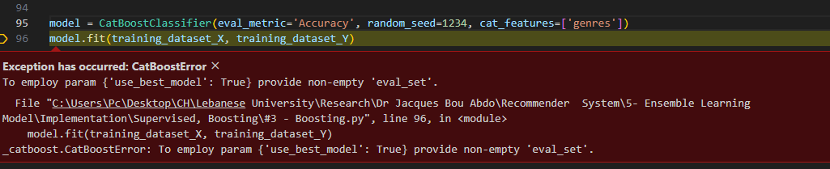

**Categorical Encoding**: CatBoost uses a technique called "ordered boosting" which helps handle categorical features efficiently. The categorical feature (genres in this case) is transformed internally into a format that captures the relationships and distributions.

* Multi Labels should be handled

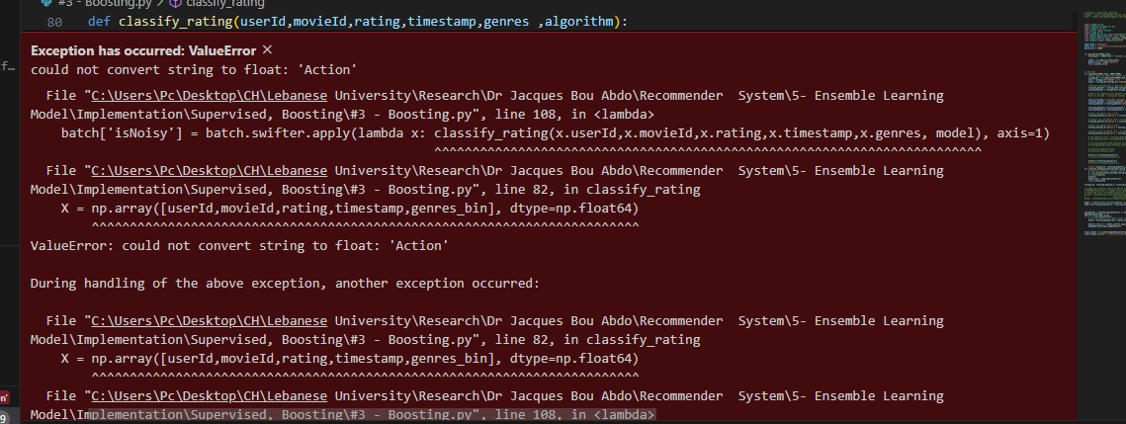

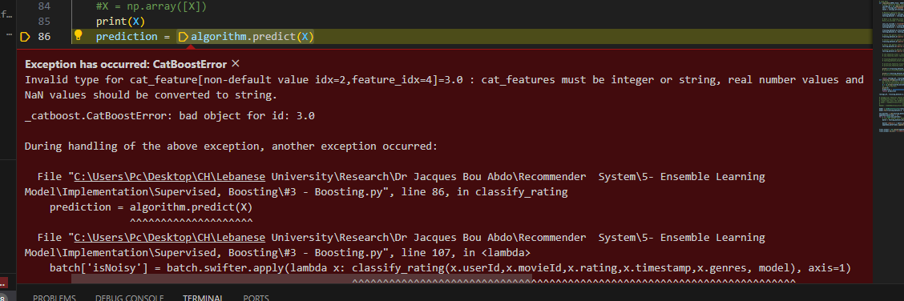 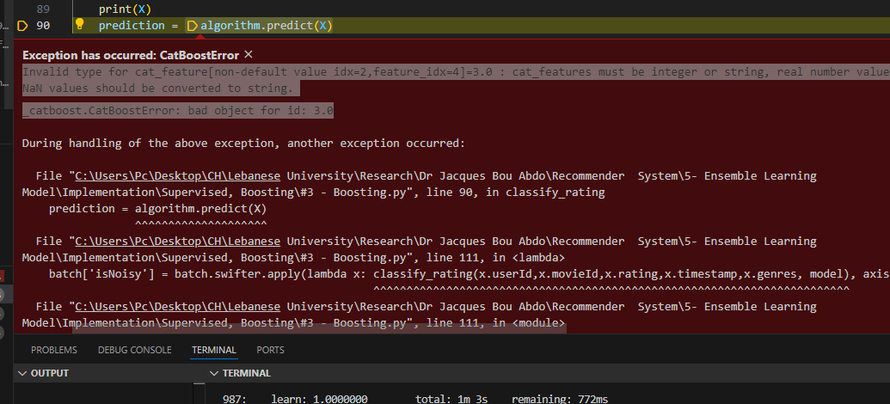

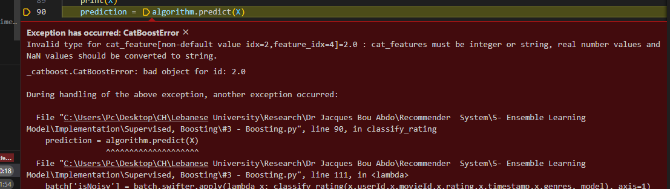

Meshe l hal fi force str aal genres